330-297-3456  November 2017 | Portage County Senior Center  705 Oakwood St.  Ravenna, Oh 44266  Ground Floor
8am-3pm 8am-3pm 8am-3pm 8am-3pm 8am-3pm
Monday | Tuesday | Wednesday | Thursday | Friday | Saturday | Sunday
 |  | 1 | 2 | 3 | 4 | 5
 |  | •Brookdale Blood  Pressure 9:30  •Bingo 10:30 | •Wii Bowling 9:00  •Tai Chi 10:30 | •Art Group 9:00  •Cards & Dominos  1-3
6 | 7 | 8 | 9 | 10 | 11 | 12
•Bingo 10:15  •Tai Chi 10:30 |  | •HEAP 9:00  •Healthy Eating 9:45  •Bingo 10:30  •UHcare 12:00 | •Wii Bowling 9:00  •Tai Chi 10:30  •MAP&OSHIIP 10:00 | •Art Group 9:00  •Cards & Dominos  1-3
13 | 14 | 15 | 16 | 17 | 18 | 19
•Bingo 10:15  •Tai Chi 10:30 | River’s Casino Trip  Cancelled | •HEAP 9:00  •Bingo 10:00  •Thanksgiving  Luncheon 11:30  (Please sign up) | •Wii Bowling 9:00  •Foot Care with  Jennifer 9:00  •Tai Chi 10:30 | •Art Group 9:00  •Cards & Dominos  1-3
20 | 21 | 22 | 23 | 24 | 25 | 26
•Bingo 10:15  •Tai Chi 10:30 | •Game Day 9-11 | •HEAP 9:00  •Bingo 10:30 | 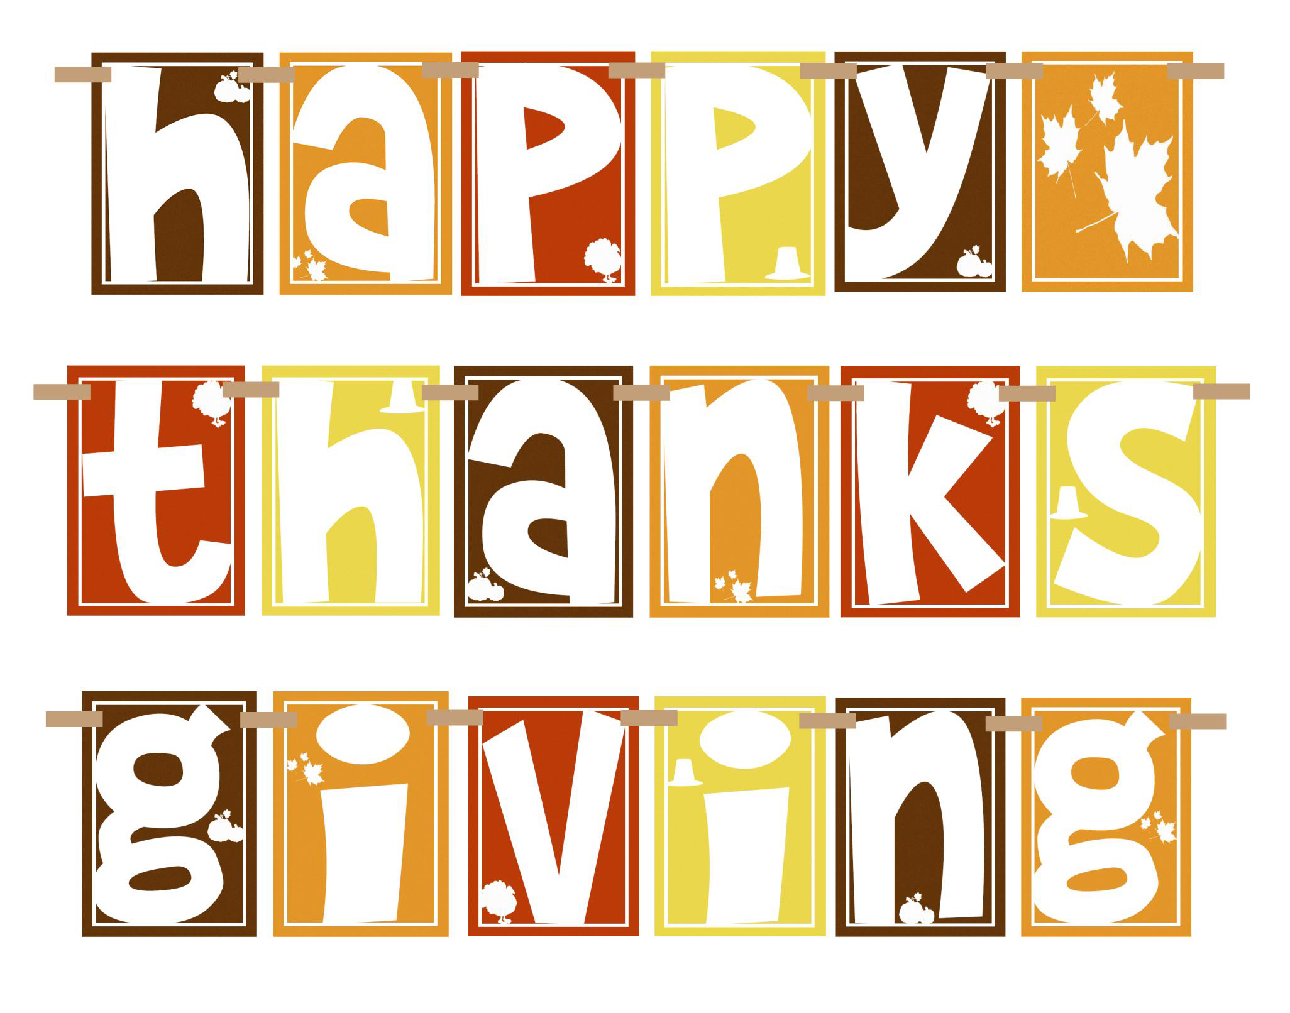 | Closed
27 | 28 | 29 | 30
•Bingo 10:15  •Tai Chi 10:30 | •Game Day 9-11  •Coaster Set Craft  9-11:30  (By sign-up only) | •HEAP 9:00  •CHAIR YOGA 9:45  •BINGO 10:30 | •Wii Bowling 9:00  •Tai Chi 10:30
**Lunch is served at 11:30 and is by reservation only. (Please sign up. Number of meals are called in on Wednesday)
**All programs and activities are subject to change.

